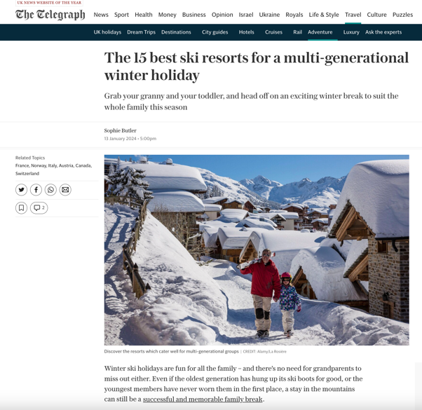



https://www.telegraph.co.uk/travel/ski/best-ski-resorts-multi-generational-skiing-families/

